# PROJECT DEVELOPMENT PHASE

**Sprint - 3**

|  |  |
| --- | --- |
| Date | 13 November 2022 |
| Team ID | PNT2022TMID44624 |
| Project Name | Signs with Smart Connectivity for Better Road Safety |
| Maximum Marks | 20 Marks |

**Step – 1:**

Creating Link for connecting with the MIT app Inventor and get output on that link.

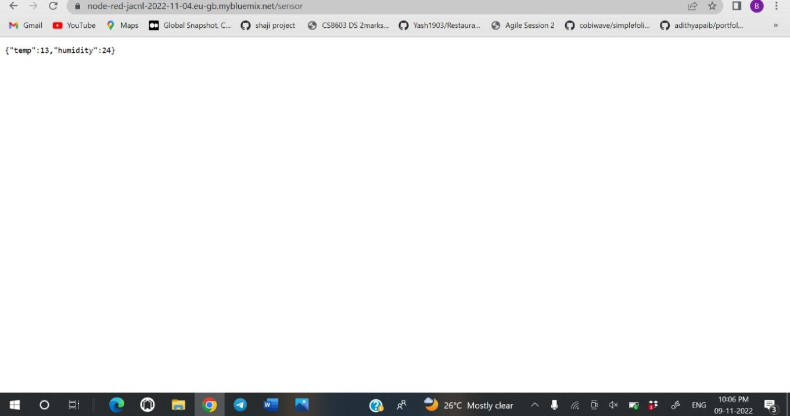

# Step – 2 :

Create the front end on MIT App Inventor:

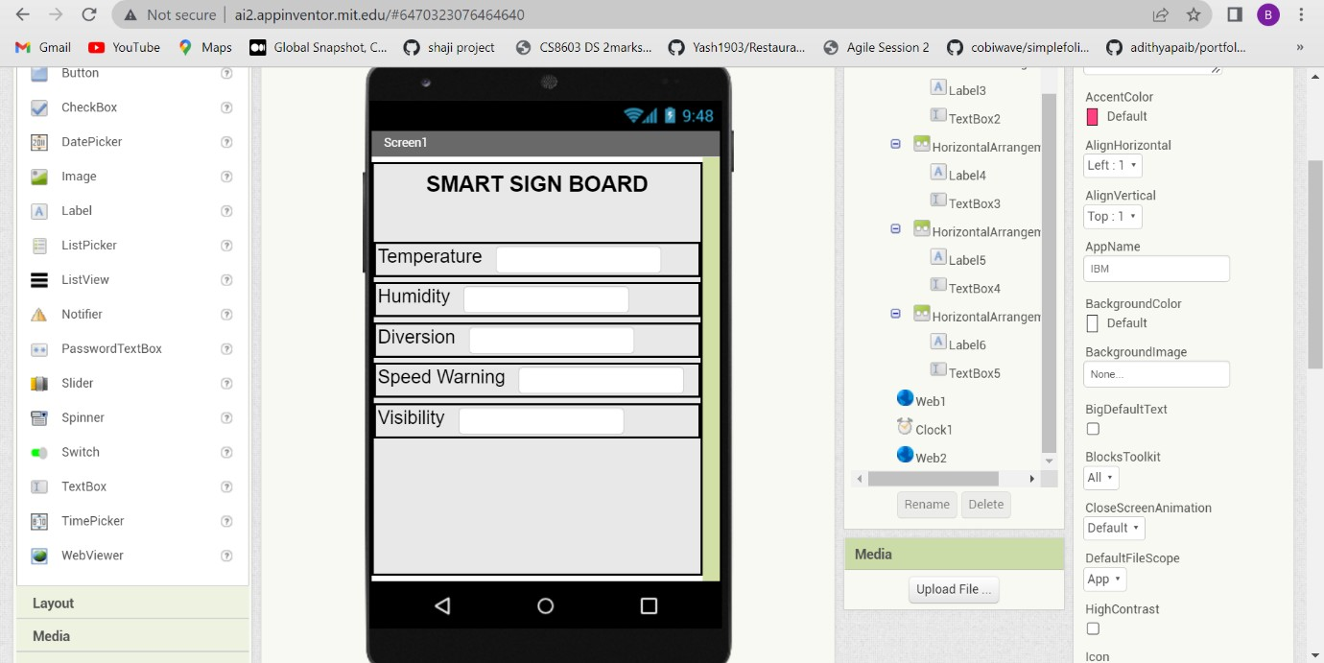

# Step- 3:

Connecting created Node-RED link with the MIT App inventor

